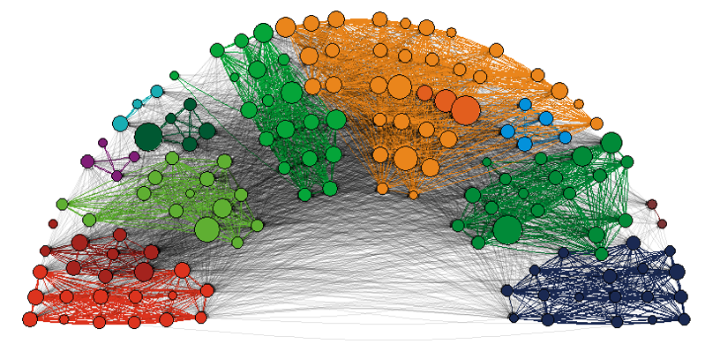

**Panel a.** Follower relations

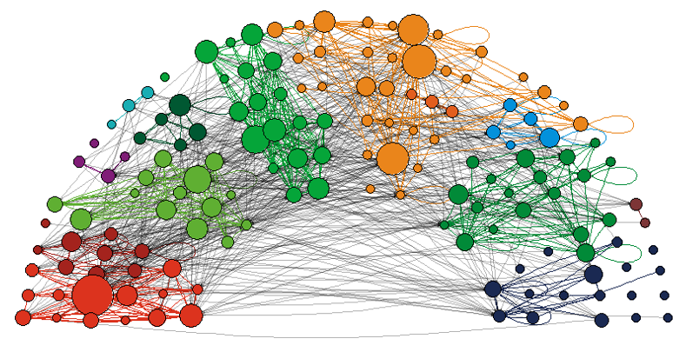

**Panel b.** @-mentions

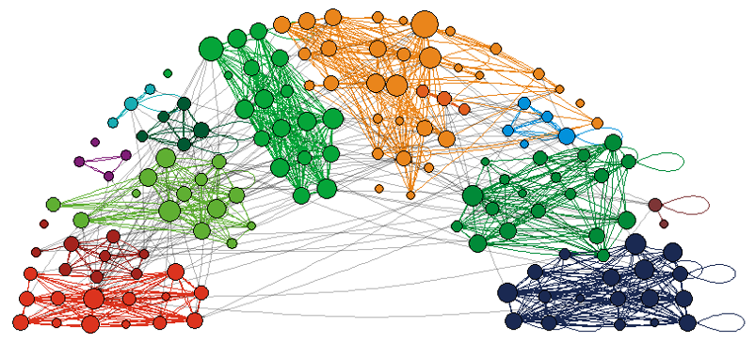

**Panel c.** Retweets

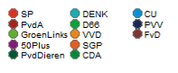

**Figure 1.** Directed twitter relations between Dutch MPs (2017)

*Notes: Node size based on degree. Edge color based on Party affiliation, black if MPs from different party*

|  |  |  |  |  |  |  |  |  |  |
| --- | --- | --- | --- | --- | --- | --- | --- | --- | --- |
| **Table 1.** Inter- and intra-group densities within the three Twitter layers among Dutch MPs (2017) | | | | | | | | | |
|  | **following T1** | **following T2** | **following T3** | **@-mentions T1** | **@-mentions T2** | **@-mentions T3** | **retweets T1** | **retweets T2** | **retweets T3** |
| total | 0.25 | 0.28 | 0.28 | 0.05 | 0.04 | 0.01 | 0.05 | 0.03 | 0.03 |
| same party | 0.71 | 0.73 | 0.74 | 0.20 | 0.14 | 0.06 | 0.34 | 0.25 | 0.25 |
| different party | 0.19 | 0.22 | 0.22 | 0.03 | 0.02 | 0.01 | 0.01 | 0.01 | 0.01 |
| same sex | 0.26 | 0.29 | 0.29 | 0.05 | 0.04 | 0.01 | 0.05 | 0.03 | 0.03 |
| different sex | 0.24 | 0.27 | 0.27 | 0.04 | 0.03 | 0.01 | 0.05 | 0.03 | 0.03 |
| same age (<6) | 0.29 | 0.31 | 0.31 | 0.06 | 0.04 | 0.01 | 0.05 | 0.04 | 0.04 |
| different age (>5) | 0.24 | 0.26 | 0.26 | 0.04 | 0.03 | 0.01 | 0.04 | 0.03 | 0.03 |
| same ethnicity | 0.27 | 0.29 | 0.29 | 0.05 | 0.04 | 0.01 | 0.05 | 0.03 | 0.03 |
| different ethnicity | 0.21 | 0.24 | 0.24 | 0.05 | 0.03 | 0.01 | 0.04 | 0.03 | 0.03 |

|  |  |  |  |  |  |  |  |  |  |
| --- | --- | --- | --- | --- | --- | --- | --- | --- | --- |
| **Table 2.** Newman’s Assortativity Coefficient within the three Twitter layers among Dutch MPs (2017) | | | | | | | | | |
|  | **following T1** | **following T2** | **following**  **T3** | **@-mentions T1** | **@-mentions T2** | **@-mentions T3** | **retweets T1** | **retweets T2** | **retweets T3** |
| party | 0.22 | 0.20 | 0.20 | 0.39 | 0.39 | 0.47 | 0.82 | 0.83 | 0.83 |
| sex | 0.04 | 0.03 | 0.04 | 0.10 | 0.04 | 0.06 | 0.01 | -0.01 | 0.02 |
| age | 0.05 | 0.04 | 0.04 | 0.09 | 0.02 | 0.12 | 0.02 | 0.01 | 0.06 |
| ethnicity | 0.06 | 0.05 | 0.05 | 0.08 | 0.02 | -0.07 | 0.09 | 0.02 | 0.04 |

|  |  |  |  |  |  |  |
| --- | --- | --- | --- | --- | --- | --- |
| **Table 3.** Multiplex RSiena model to predict twitter relations among (147) Dutch MPs in 2017: summary of main results from Model 1, 2, 3 and 4 | | | | | | |
|  | b | se | b | se | b | se |
|  | *following* | | *@-mentions* | | *retweets* | |
|  | *Model 1* | | | | | |
| same party | 1.083 | 0.146 | 0.918 | 0.054 | 1.386 | 0.078 |
|  | *Model 2* | | | | | |
| same party | 1.088 | 0.150 | 0.922 | 0.064 | 1.388 | 0.099 |
| same sex | 0.129 | 0.086 | 0.054 | 0.054 | 0.127 | 0.049 |
| (absolute) age difference | 0.035 | 0.007 | 0.000 | 0.003 | 0.001 | 0.004 |
| same visible ethnic minority status | -0.390 | 0.152 | 0.073 | 0.055 | 0.121 | 0.083 |
|  | *Model 3* | | | | | |
| same party | 0.755 | 0.189 | 0.406 | 0.106 | 1.106 | 0.093 |
| same sex | 0.130 | 0.087 |  |  | 0.115 | 0.056 |
| (absolute) age difference | 0.034 | 0.007 |  |  |  |  |
| same visible ethnic minority status | -0.410 | 0.145 |  |  | 0.134 | 0.094 |
| retweets | 1.718 | 0.536 | 0.454 | 0.212 |  |  |
| reciprocity with retweets | 0.677 | 0.483 | 0.245 | 0.181 |  |  |
| following |  |  | 0.400 | 0.072 | 0.647 | 0.092 |
| reciprocity with following |  |  | 0.158 | 0.066 | 0.251 | 0.076 |
| @-mentions |  |  |  |  | 0.801 | 0.228 |
| reciprocity with @-mentions |  |  |  |  | 0.988 | 0.231 |
|  | *Model 4* | | | | | |
| same party | 1.215 | 0.157 | 0.804 | 0.060 | 1.386 | 0.079 |
| period*same party | 0.957 | 0.278 | -0.448 | 0.099 | 0.265 | 0.056 |

Notes:

Parameters estimates with a *t*-value smaller than one were dropped to obtain an acceptable model fit. The full results of these models can be accessed via our replication website (***).